**AlbumController – Build List Album API**

**Add below code in AlbumRepository.java**

 List<Album> findByAccount_id(long id);

**Add below code in AlbumService.java**

 public List<Album> findByAccount_id(Long id){

        return albumRepository.findByAccount_id(id);

    }

**Add below code in AlbumController.java**

//List all the albums based on the logged in users

    @GetMapping(value = "/albums", produces = "application/json")

    @ApiResponse(responseCode = "200", description = "List of albums")

    @ApiResponse(responseCode = "401", description = "Token missing")

    @ApiResponse(responseCode = "403", description = "Token Error")

    @Operation(summary = "List album api")

    @SecurityRequirement(name = "studyeasy-demo-api")

    public List<AlbumViewDTO> albums(Authentication authentication){

        String email = authentication.getName();

        Optional<Account> optionalAccount = accountService.findByEmail(email);

        Account account = optionalAccount.get();

        List<AlbumViewDTO> albums = new ArrayList<>();

        for(Album album : albumService.findByAccount_id(account.getId())){

            albums.add(new AlbumViewDTO(album.getId(), album.getName(), album.getDescription()));

        }

        return albums;

    }

**Output**

**If the user is user**

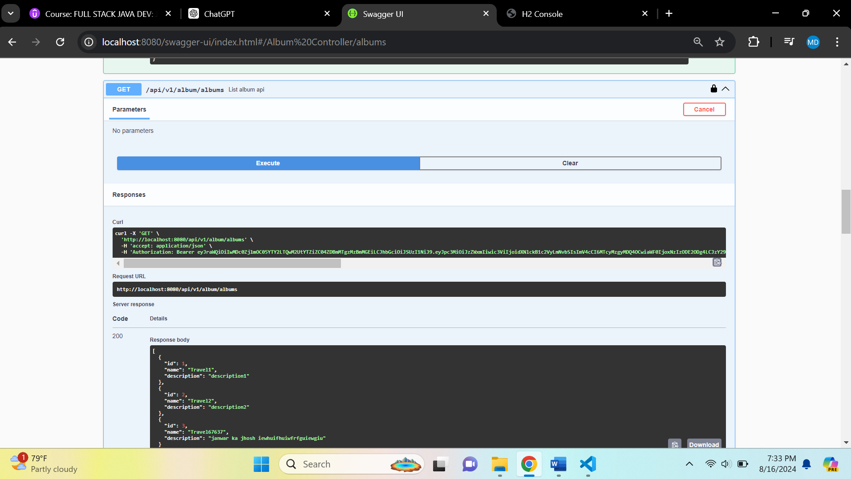

**Db console**

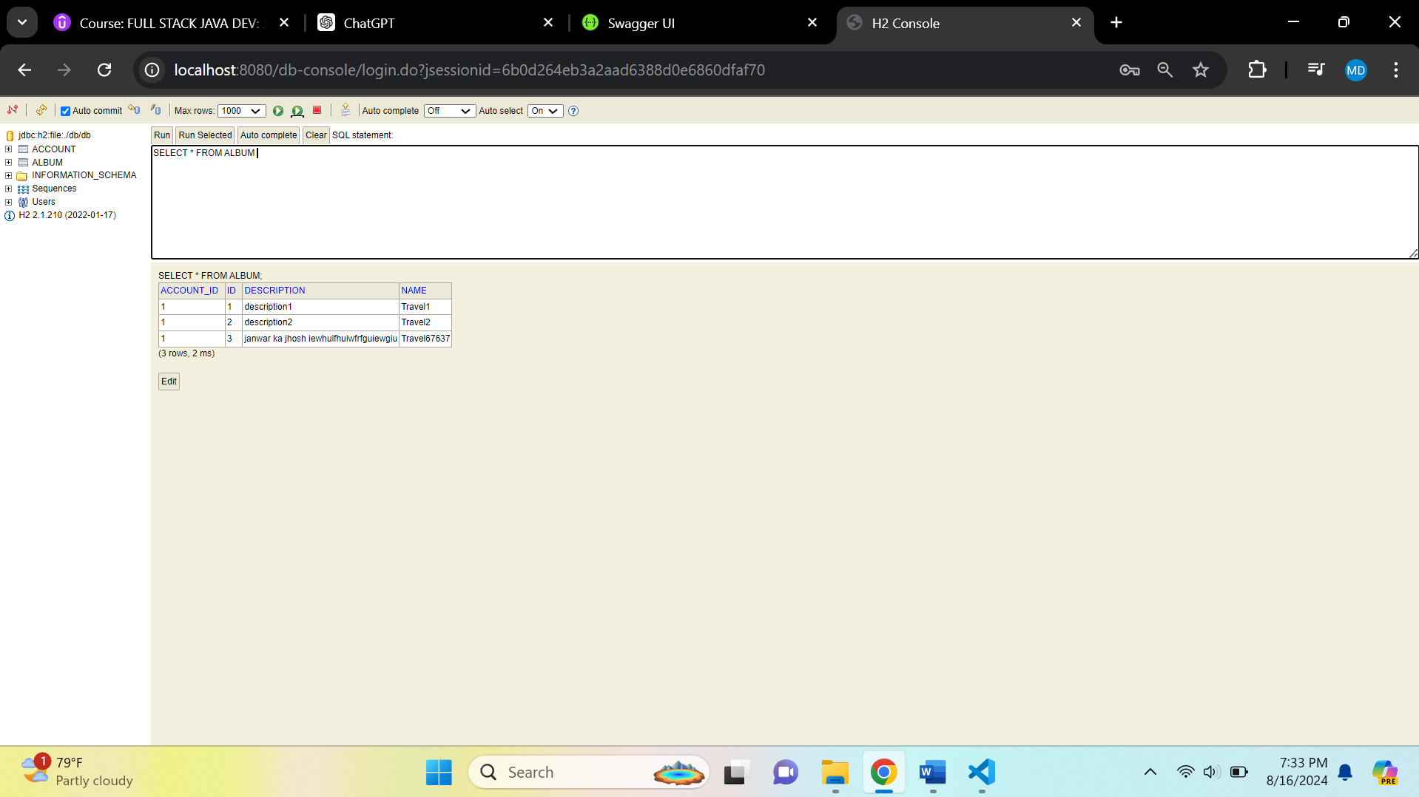

**If the user is admin**

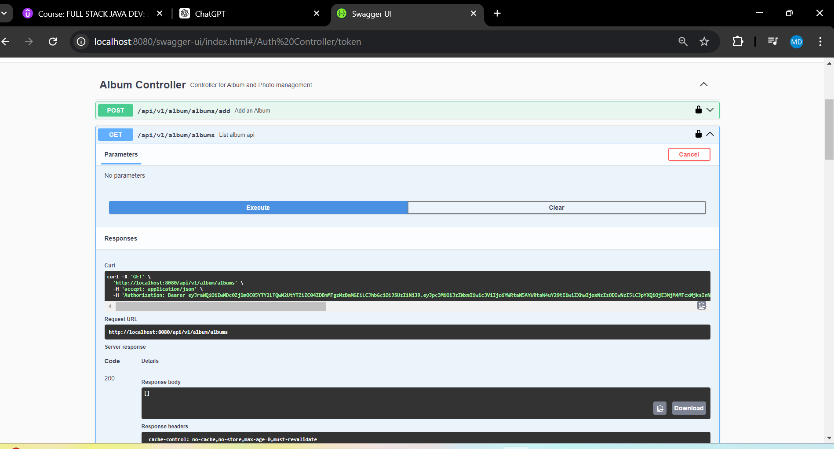

**If albums added**

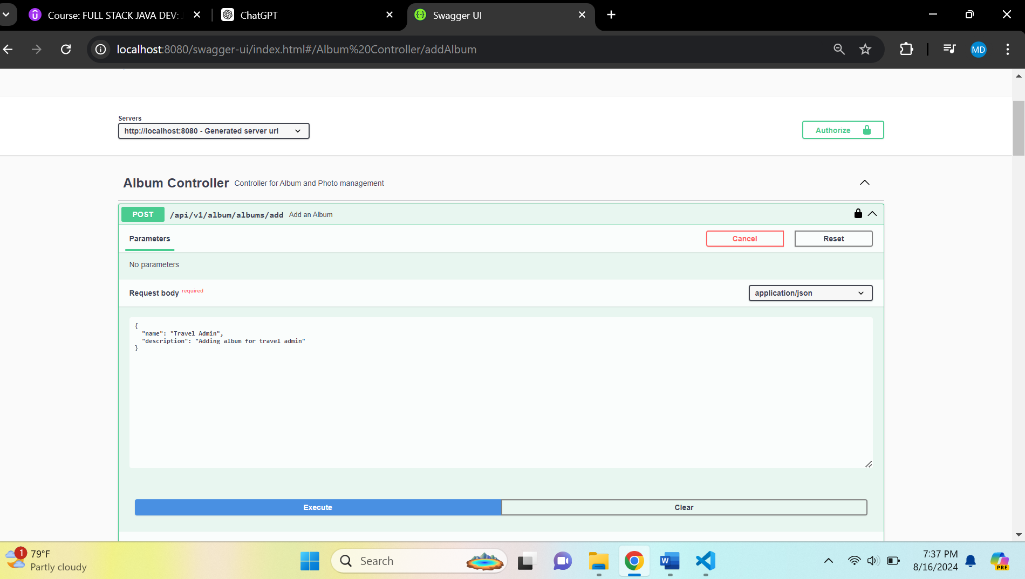

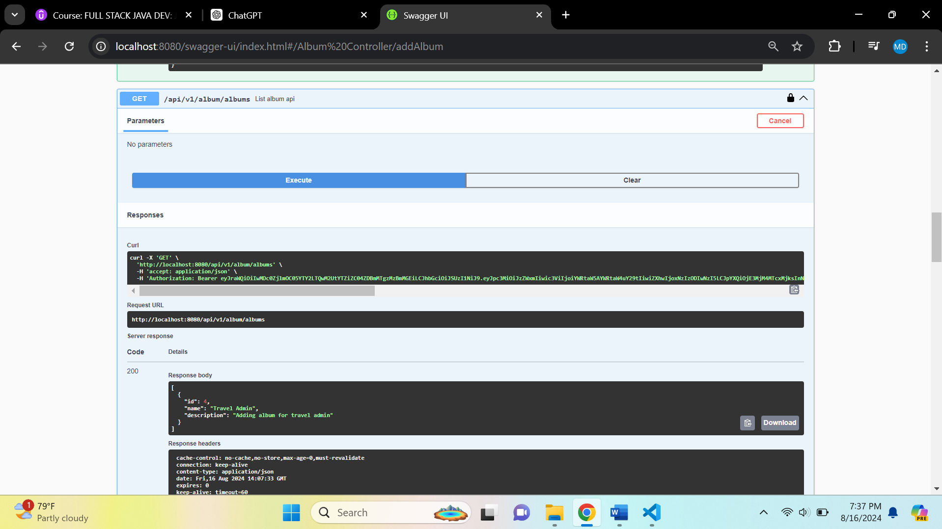

**Db Console**

